Saint Louis Public Schools Early Childhood Education Department
Pre-Kindergarten Communication Log
Week (date) | Teacher Name | Site Name | # of Students
January 11 – 15, 2021 | Ms. Eller and Mrs. Watters | Lexington
Pre-K families will receive ongoing communication throughout the Virtual Learning time period.
- Twice weekly, teachers will communicate with families via Zoom, phone or Class Dojo
- Weekly, teachers will provide 5 activities, 3 read-alouds and 2 lessons on their webpage for families to access
Objective | Letter Rr, words that begin with the letter R, Number 18, Composing numbers, sports, Patterns, and Sorting, MLK, hibernation, etc.

Webpage Assignments   | Complete 4 name sheets from bankers box
 | Complete Letter Rr pages in premade workbook from bankers box.
 | Complete Number 18 pages in premade workbook from bankers box
 | Go to ABCYA.com and play the pattern game called Fuzz Bugs.
 | Write one to two sentences about snow and some snow activities that you cando.

Webpage Read-Aloud   | Charlie Crow in the Snow Read Aloud:  https://www.youtube.com/watch?v=SSAOV7DdGgk
Snowman Magic Read Aloud
https://www.youtube.com/watch?v=6uPOQ8RELvg

The Snow Day Read Aloud
https://www.youtube.com/watch?v=FmZCQfeWjeQ

Webpage Lessons  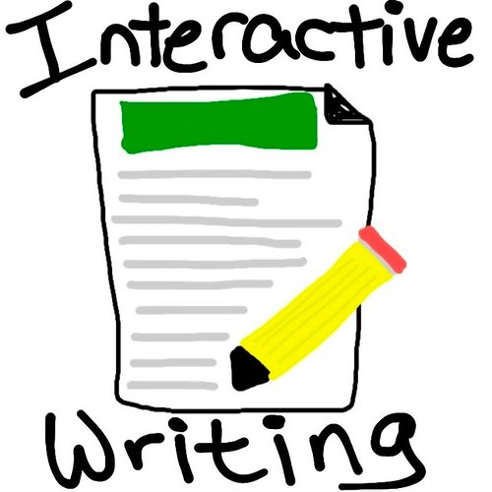 | Please visit our Teams page for recordings.
 | Please visit our Teams page for recordings.

